

Department of Mechanical Engineering
ME 490 B

Solar Desiccant Air Conditioner

Luis Hernandez
Joel Heywood
Abhishek Kumar
Yzzer Roman

Advisor: Dr. Fletcher Miller
Table of Contents Page
- Abstract ………………………………………………………………………………. 3
- Nomenclature ………………………………………………………………………… 3
- Executive Summary ………………………………………………………………….. 4
- Introduction
4.1 Project Definition …………………………………………………………………... 6
4.2 Team Assignments ………………………………………………………………… 6
5. Design
5.1 Specifications …………………………………………………………………….... 7
5.2 Concepts …………………………………………………………………………... 8
5.3 Analysis …………………………………………………………………………… 10
5.4 Preliminary Testing ……………………………………………………………….. 12
5.5 Design Solution …………………………………………………………………… 13
6. Prototype Design …………………………………………………………………….. 13
7. Final Design and Test Results ……………………………………………………….. 16
8. Conclusions & Recommendations …………………………………………………… 19
9. Acknowledgements ………………………………………………………………….. 21
10. Appendixes ………………………………………………………………………….. 22
11. References …………………………………………………………………………… 28

Abstract
Going green and conserving as much energy as possible has become the focal point in the eyes of the world. There are many sources of energy available to us that will conserve our natural resources and cut down on harmful emissions that are destroying our environment. Many incentives are now available to individuals and industries who implement the use of these environmentally friendly sources of energy. Our design and construction of a solar desiccant air conditioner is a new alternative to air conditioning that uses far less electricity and also uses energy from the sun to run the system. We set out to create an air conditioner that does not create any harmful emissions and cuts down on the electricity cost to a home owner. The solar desiccant air conditioner uses solar power as the main energy source to help in the thermodynamic heat transfer process as well as heat transfer principles to convert ambient air into cool air. With our constructed design we have seen temperature as well as humidity level drops throughout the desiccant cooling system.
Nomenclature
CAD – Computer Aided Design
Desiccant – silica gel and clay adsorptive material used to remove humidity from the air.

Executive Summary
The design and construction of the solar desiccant air conditioner was created to be an alternative product that home owners could use to cool down their homes while using environmentally friendly sources of energy. The project began by researching different ways to create an air conditioner that would mainly use the sun as an energy source. We designed a solar adsorption cooling system that extracts the heat from the air by means of dehumidification and heat exchange. The output of cold air is to serve a conditioned room. The design includes theoretical calculations on expected outcomes, calculations to find the correct size pump, desiccant and recovery wheel, and CAD drawings of the cooling system and the entire system to create a good fit and verify the strength of the system. The cooling system design is made up of a desiccant wheel, a regeneration wheel, two fans, and a heat exchanger.
There are two separate air heat transfer processes that take place in the system. One air process heats the air and the other cools the air. In the hot air process, the heat exchanger takes hot water that was heated from our donated SunMaxx Solar 10 evacuated tube solar collector and transfers the heat to air passing through the system. That hot air is then used to add moisture to the desiccant wheel in order to return it to its normal state. The desiccant wheel is made of silica gel pellets as well as a clay desiccant material which is enclosed in a wheel made of aluminum and is held in by a netting material. When ambient air is passed through the desiccant wheel, the humidity level decreases and the temperature increases slightly. In the cool air process, ambient air is first sent through the desiccant wheel where the humidity decreases then it is sent through the recovery wheel where heat transfer takes place and turns the air into cooler air. The recovery wheel is made up of aluminum fins incased in a wheel that move the hot air to the hot air process side while pushing the cool air out of the system. The air is also cooled while coming into contact with the aluminum fins.
We tested our system many different times to verify humidity level drops, find the correct size pump, and to verify our theory that the temperature would decrease after the desiccant cooling process took place. The testing of the entire system showed a maximum temperature drop of 3.8 degrees Fahrenheit. We believe that with further testing on a warmer day the temperature change would be greater based on our theoretical calculations.

Introduction
Project Definition
The solar desiccant air conditioner began with the donation of the SunMaxx Solar evacuated tube solar collectors. Our team was informed of a project that would use these collectors along with heat transfer properties that would create air conditioning using renewable sources of energy. We designed the system to be environmentally friendly and also make it affordable if people wanted to utilize this technology in their own home. We also wanted to see how large a room could be cooled by only using the ten evacuated tube solar collectors that we possessed. Initial concepts on how to create cooling were brainstormed until we decided to use adsorption and use silica gel as our desiccant material. With our concept selected we used software as well as engineering principles to select the correct size and materials we needed to create an air conditioner. Our team was divided into two groups to research and design different portions of the desiccant air conditioning system.
Team assignments
We divided our team into the solar collector team and cooling system team. Joel and Yzzer were designated to the solar collector team and were tasked with finding feasible liquids to be run through the collector, find the maximum temperatures achievable by the collectors, and to find the most effective way to make the collectors the most efficient. Luis and Abhishek were designated to the cooling system team and were tasked with researching the cooling process, finding the types of materials to use, and the most efficient way to perform the cooling. For the design and build of the system Joel created the box to house the entire system and Luis, Abhishek, and Yzzer worked on the inner workings of the heat transfer processes. All members performed the testing together and made changes to the system as a team when problems were encountered.
Design
Specifications
The solar desiccant air conditioner performance was restricted by heat gain from the sun. Needless to say, the hotter the day would result in the better conditions for our design. Another constrain was system transportation because the collector is larger than the laboratory door frame and this created a big problem for us, since we needed to take the system in and out of the room for testing. We also had a budget problem since we did not have any sponsors other than the donated collector. We bought cheaper parts and made most of the system ourselves because it was student sponsored. The collector that we used was a SunMaxx Solar 10 evacuated tube solar collector donated from Silicon Solar. The materials used for the construction of the system include items that can be found at local stores or are easily available. Plywood was used in the construction of the platform to hold the entire system and also used to insulate the air processes that made up the cooling box. We used standard schedule 40 PVC pipe to carry the heated water through the system because we did not exceed the temperature limit of the pipe. The blowers and heat exchanger were bought used from old vehicles to help keep our cost low. We also used Styrofoam and plastic to help funnel the air that was being transported through the cooling box. The silica gel and clay desiccant materials we used in the final design were bought on line and we filled the wheels with desiccant pellets instead of buying a pre-assembled wheel. The heat recovery wheel was made out of aluminum sheets to help in the cooling process. We used water as the working fluid in the system because it is easily available and cheap compared to other fluids.
Concepts
To accommodate for heat gain from the sun we added a tilt angle on the solar collector to face the suns radiation to acquire the most heat. Also, we added aluminum foil sheets behind the solar tubes to reflect the suns radiation from the bottom side of the collector tubes. For transportation we had a few design solutions: 1) was to add single casters on each of the collector’s legs and have two mobile units, the cooling unit and the solar water heater unit, 2) mount the cooling unit and collector on a four wheeler platform and un-bolt and fold the collector when going through doors, 3) mount both the collector and the cooling unit on a four wheeler platform, this wheeler had u-shaped cuts on the sides, when going through doors the system will be able to turn easily as a single unit. For the cooling unit the concept was clear from the beginning and would include two wheels driven by the same shaft and two fans with one on the top side and one on the bottom side.
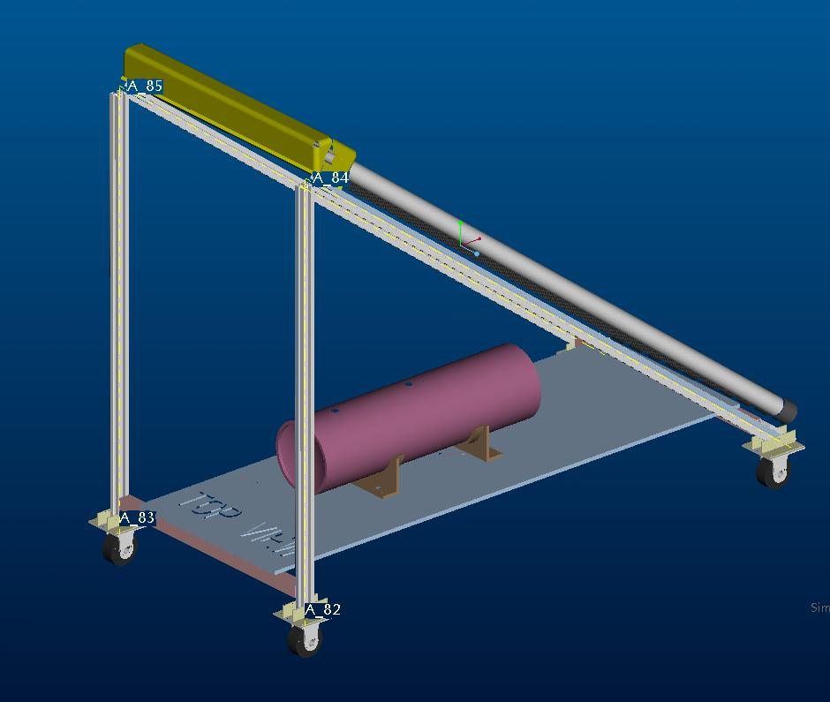  Concept 1 | 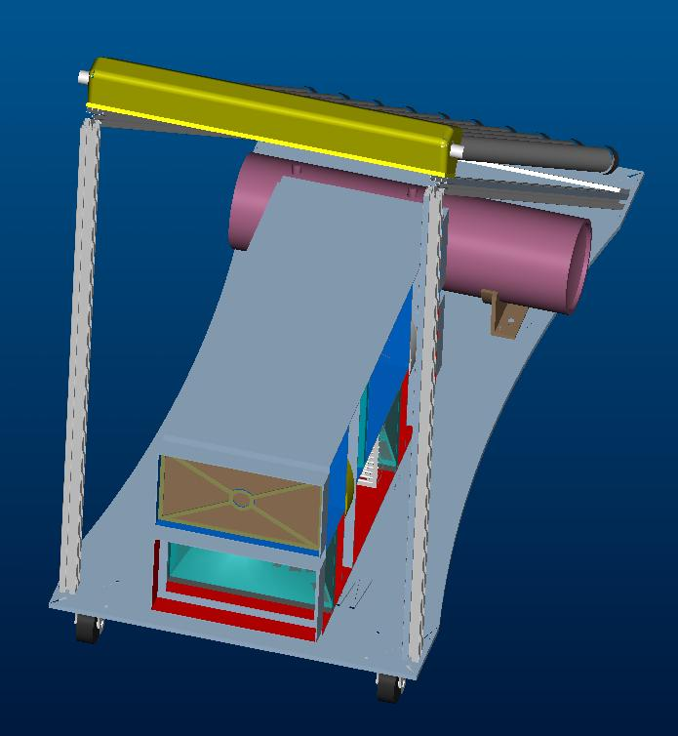  Concept 3
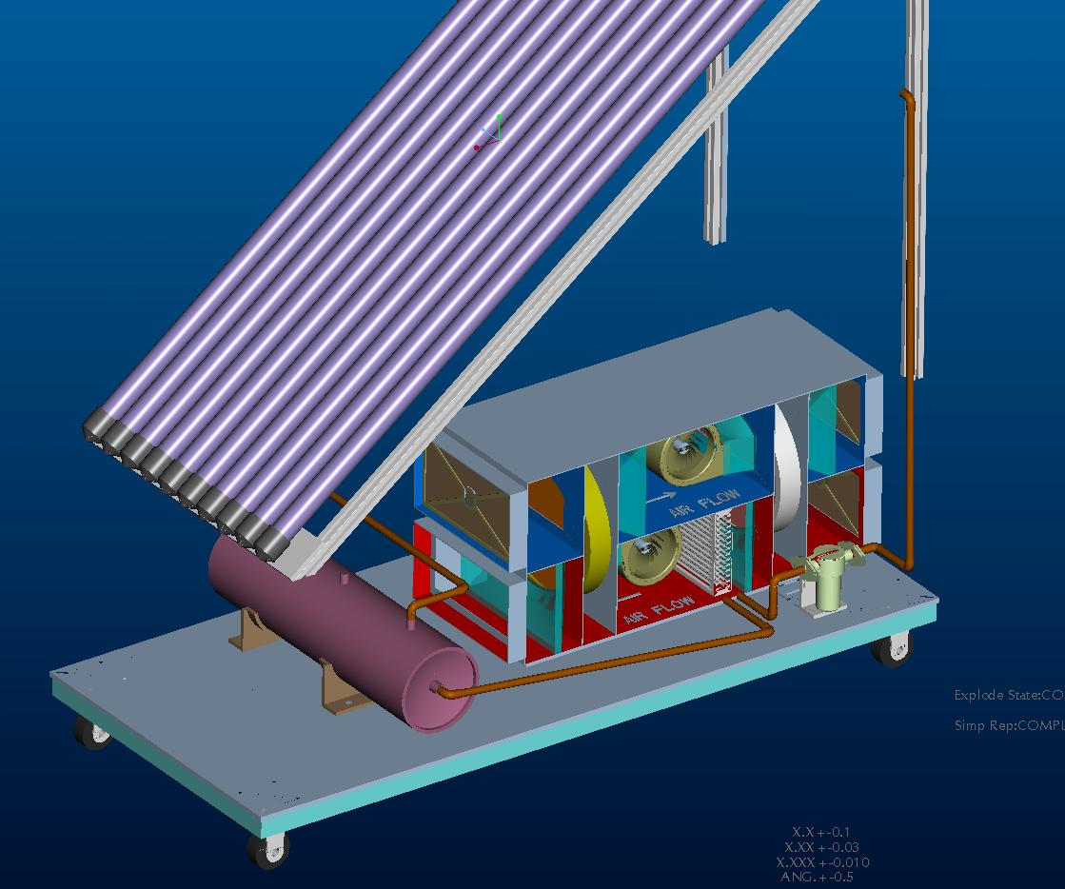
Concept 3

Analysis
FEA analysis was conducted on the platform to make sure the wood would hold the total weight of the system. After reviewing the analysis it was concluded that the platform would be strong enough to hold the collectors as well as the desiccant cooling heat transfer box. Computer software was also used to design and analyze the size of desiccant wheels to be implemented as well as the anticipated temperature outputs based on our flow rate and humidity levels. We experimented with different air flow rates while changing the humidity levels slightly to help in the selection of the appropriate desiccant wheel diameter. The selection of the water pump was based on testing done after the recommended pump size was not large enough to pump the water through the entire system.

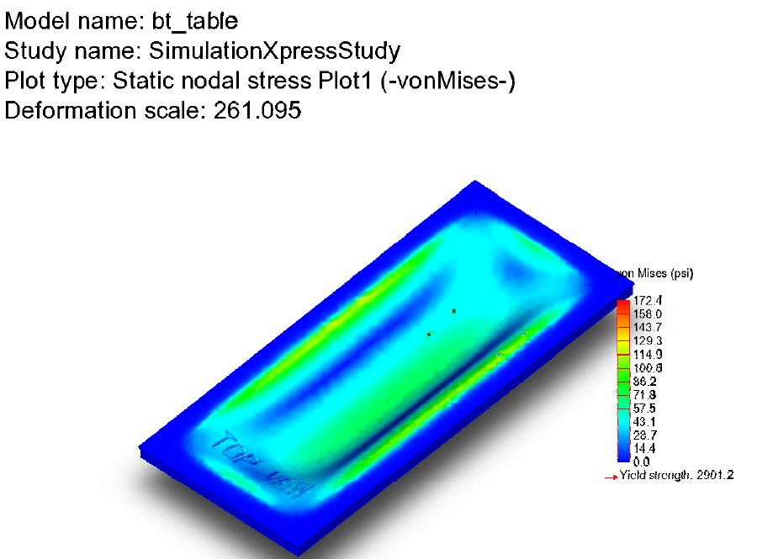
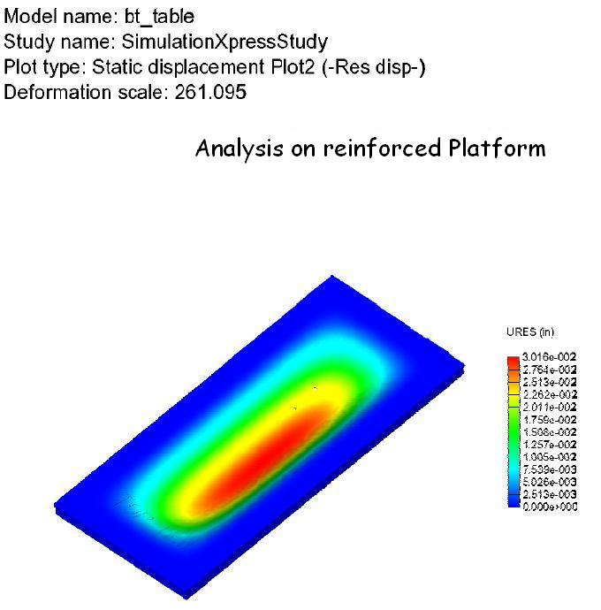

Preliminary Testing
We set up a test box so that we could test what temperature and humidity level changes occurred through the heat exchanger. We had a fan set up on one side to remove the hot air when it passes through the heat exchanger. With this set up, we experienced a temperature increase and a humidity level decrease. This is also expected for the air passing through the desiccant wheel.

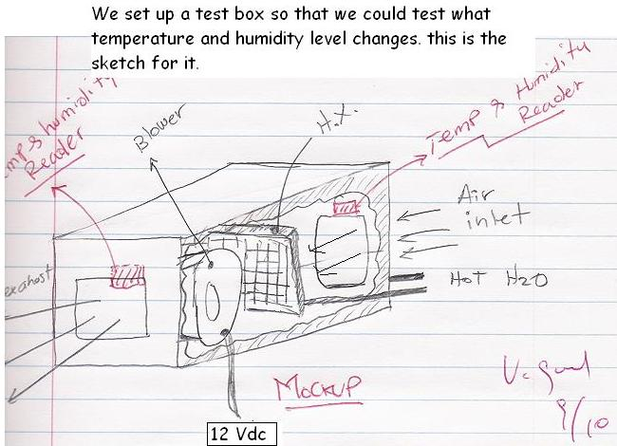
 | Temperature (F) | Humidity (%)
30 Minutes  Inlet  Outlet | 78  83 | 43  38
40 Minutes  Inlet  Outlet | 75  85 | 47  32

Design Solution
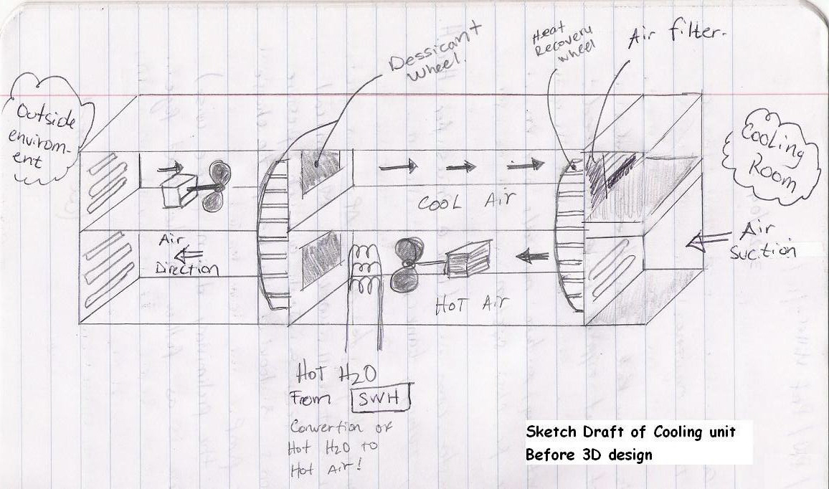
This figure shows a sketch of the cooling unit.

Prototype Design
The prototype design consisted in a CAD design of the main components assembled into a single structure. The system had to have the following characteristics for the purposes of this project: portability, ease of assembly and disassembly, and compact size; as well as being able to house all the equipment for the desiccant based air conditioning. To accomplish this, the cooling device assembly, the water pump, storage tank and pipes and fittings, would have to be placed on a platform built under the collector. The team decided that it would be best to have the whole system together rather than components as separate assemblies and connecting them together for testing.
The basis for the cooling device size and layout was designed around the typical desiccant wheel sizes by the company Novelaire. Using the smallest desiccant wheel in their product line, the appropriate dimensions were used for the box that would house the desiccant and energy recovery or enthalpy wheels.
The space under the solar collector was allocated for the box and the components that make up the hot water cycle. The main components for the water cycle being the pump, storage tank and piping. Although the water to air heat exchanger is part of the water cycle, it is not mentioned above since it is housed in the cooling device as part of the regenerative process of the desiccant wheel.
Using the size of commercially available expansion tanks of a minimum of 4 gallons, the CAD design was completed. All the components were assembled together and located strategically under the space under the solar collector to maximize space usage and minimize pipe turns. This way, pressure losses are minimized and the pump size can be small. The platform was tested using approximate weights to correctly size the pounds rating of the platform wheels. These wheels should not to be confused with the desiccant and enthalpy wheels. Below is the CAD prototype design that was modeled using ProEngineer.

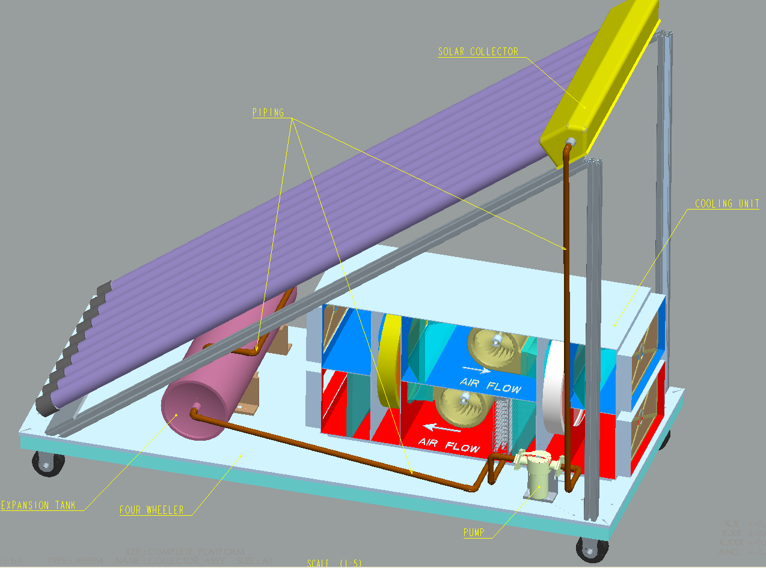

Figure 1 - Prototype Design
The actual design, however, would be heavily modified largely due to budget cuts; an occurrence common lately at SDSU. The availability of parts and the unsuspected problem of the solar collector not being able to fit through normal width doors also played an important role in the final design of the desiccant air conditioning.
Final Design and Test Results
The final design for the system had the same characteristics as the prototype, but some changes were made. First, the desiccant and energy recovery wheels were not purchased from Novelair as intended. The cost of the wheels far exceeded the allocated budget, which was completely funded by the team. This led to the construction of the wheel frame by a third party and the desiccant was obtained from an online supplier. The energy recovery wheel was also made from off the shelf materials. Literature was reviewed for the later, but no specific design was found. The wheel was then constructed to simulate the blades of a turbine mounted on a perforated aluminum plate. With a simple and economical design, the wheels were manufactured and successfully adapted to the already built cooling device frame.

The pumps for the hot water cycle were not bought from a source with full specifications and a trial-and-error stage for the pump testing was performed. The pump that had the best results was a water pump that had a rating of 150W at 120V. The actual energy usage was closer to 250W at 120V. The blowers were adapted from an automotive air conditioning system. Using plastic, an air funnel was created to direct the air. The heat exchanger was also obtained from an automotive source. Using these components originally designed for completely different applications led the team to a complicated task, adapting non-standard devices. Most if not all devices are specifically manufactured for the automotive application. Through testing and trial and error experimentation, the system was put together successfully. The blowers were rated for 12V, so the implementation of a lead-acid battery was necessary; a 12V switch was installed to control both fans.
The expansion tank that was originally specified was replaced by a 5 gallon plastic bucket that was adapted to receive the fittings of the pump. Instead of using copper piping, sections of PVC and high temperature plastic hose were utilized. This proved useful when disassembling the unit to transport it from the solar laboratory to the sunbathed parking lot on the east side of the engineering building. Below is a picture of the solar desiccant air conditioner during testing.
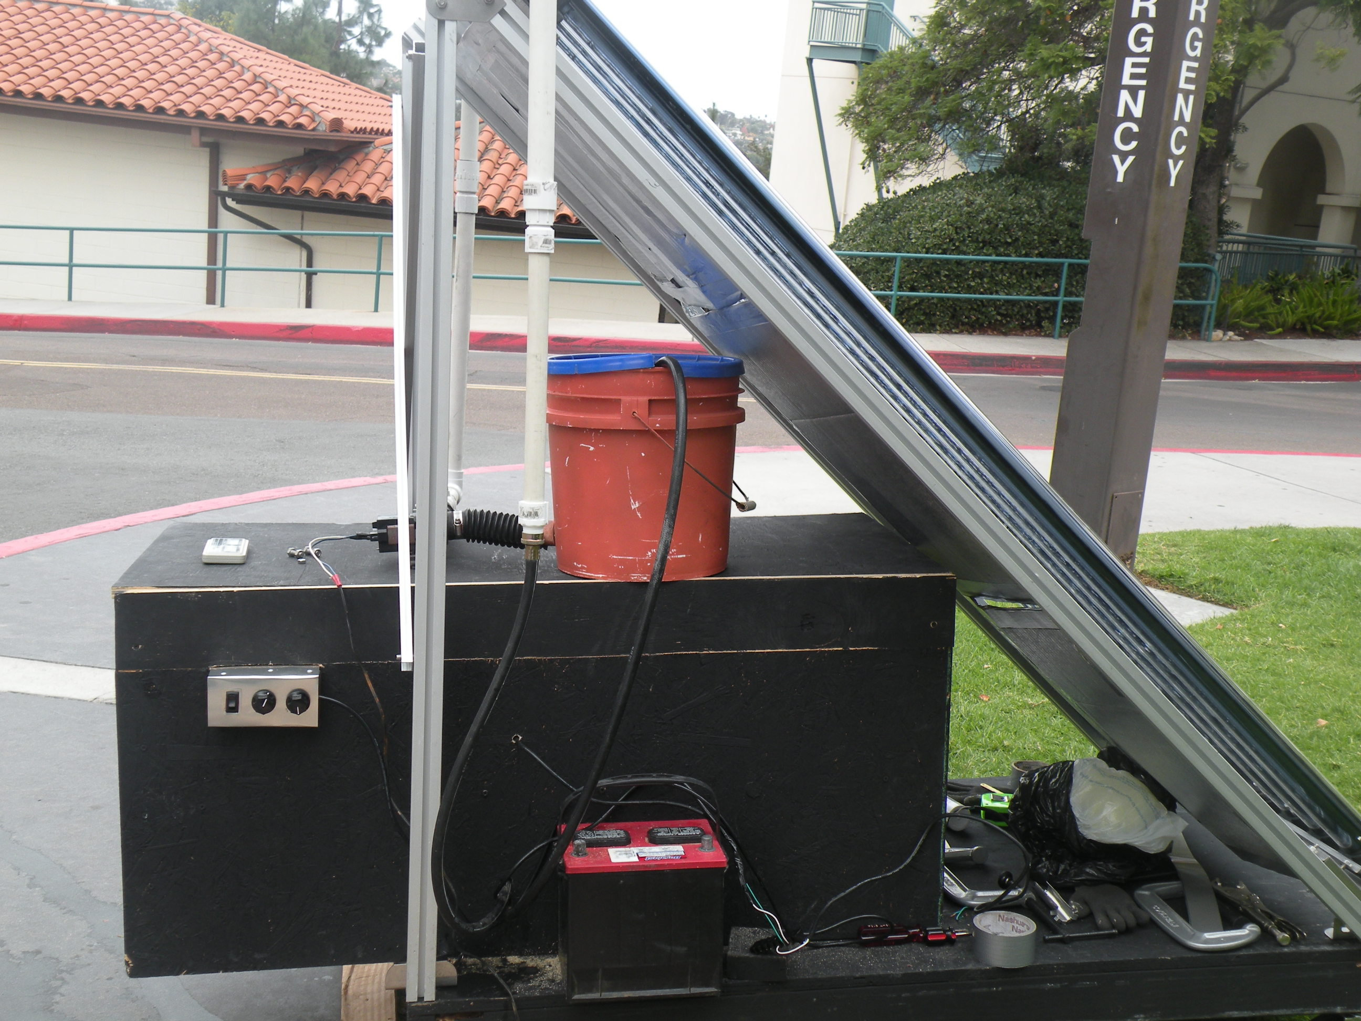

Figure 2 – Final Design
Final Test Results
These results were obtained at different times and different water temperatures and we observe that at higher temperatures we obtain a bigger temperature gradient. The air output is cooler than the air input. The water temperature that we expected, greater than 120 degrees F, was not achieved partly because the test was performed on a cloudy day.
Test | Water Temperature (deg F) | Humidity (%) | Air Temperature (deg F)
1 | 64 | 36 | 63.5 | Inlet
 |  | 35 | 62.7 | Outlet
2 | 70 | 32 | 64.0 | Inlet
 |  | 30 | 63.2 | Outlet
3 | 80 | 34 | 67.8 | Inlet
 |  | 32 | 65.0 | Outlet
4 | 86.6 | 32 | 64.8 | Inlet
 |  | 30 | 62.2 | Outlet
5 | 84.7 | 34 | 64.8 | Inlet
 |  | 30 | 61.0 | Outlet
Conclusions and Recommendations
Our Project objectives were met as we achieved a temperature gradient of 3.8 F from the ambient air. The results proved that our system will work well on a warm sunny day with temperatures above 80 F.
While there are existing desiccant cooling machines available in the market, our system is different from them as we derive power from solar energy. The process of heating water and subsequently cooling down air is not readily available in the market yet. Such a system can be improved by using desiccant wheels made in casings which include the shafts and bearings connected to the cooling wheel.
Over a period of 1 year in this project we gained immense knowledge in the field of Mechanical Engineering. Not only did we revise our concepts of design in thermodynamics, but we also got an opportunity to fabricate materials required for the project. We now understand how important planning is to perform a project successfully and within a limited timeframe.
Although we achieved our objectives for the project, a thorough test on a warm sunny day still remains. Sizing calculations need to be performed to determine the cooling load of the system we built. Also, the addition of a motor to rotate the wheels will help the overall system perform and regenerate the desiccant material.
The strengths of our project include the utilization of renewable energy for air conditioning, a system that is scalable from a residential to a commercial size, an environmentally friendly, low electric consumption, and minimal CO₂ emission system that can perform while eliminating energy hungry components that are found in a traditional air conditioning system. One of the shortcomings of our project is that our system is heavy and large in size. We would have also liked to test the system with more ideal environmental conditions, but were not able to before the end of the project.
Our system can be used for residential purposes and can be installed on top of the roof or in the lawn outside homes. The cool air will reach the desired room/buildings from a duct connected to the outlet of our system. Overall the project was a success that helped us see how the engineering design process takes place and that it takes team work as well as many design changes to complete a product.

Acknowledgements
- Dr. Fletcher J Miller
- Dr. Kee S Moon
- Mr. Mike Lester
- Silicon Solar Inc.
Thank you for all the help, ideas, and encouragement you gave us to complete our project.

Appendix
Desiccant Cooling Design
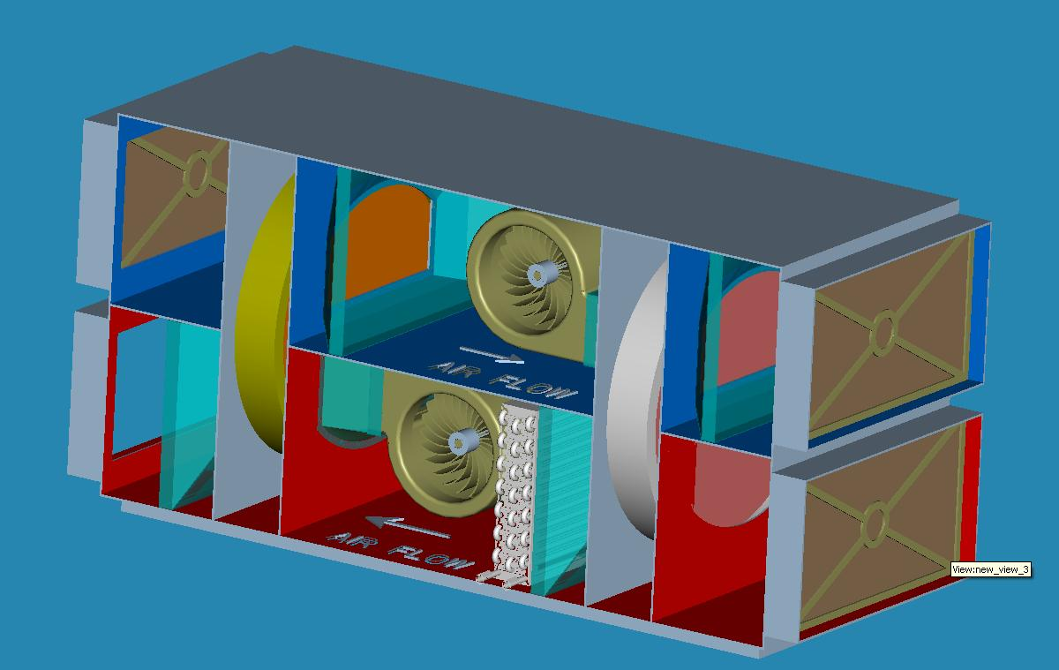
Figure 3. Design on Pro-E.
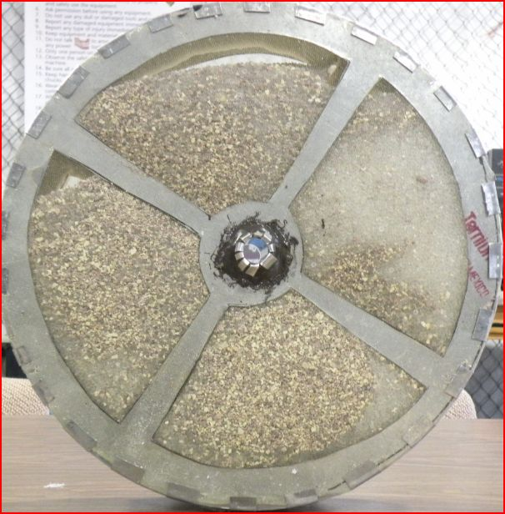
Figure 4. Desiccant wheel filled up with silica gel.
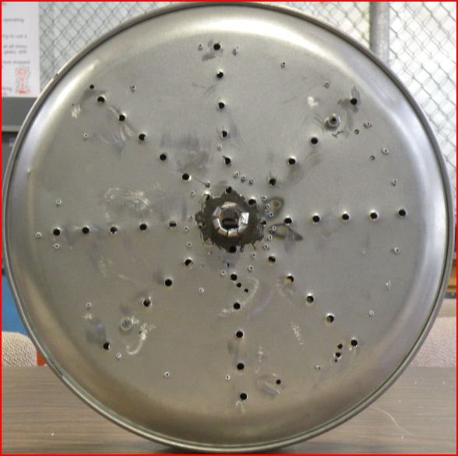
Figure 5. Heat recovery wheel with holes drilled for a smooth flow rate.
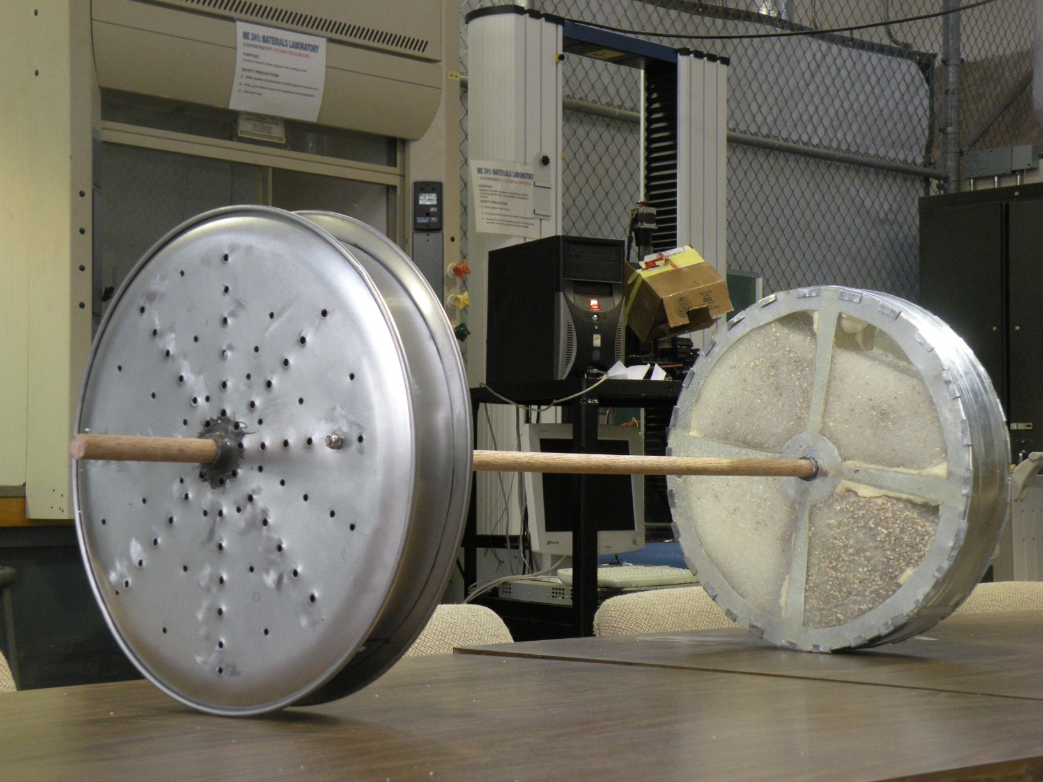
Figure 6. A spindle connects the two wheels inside the box.
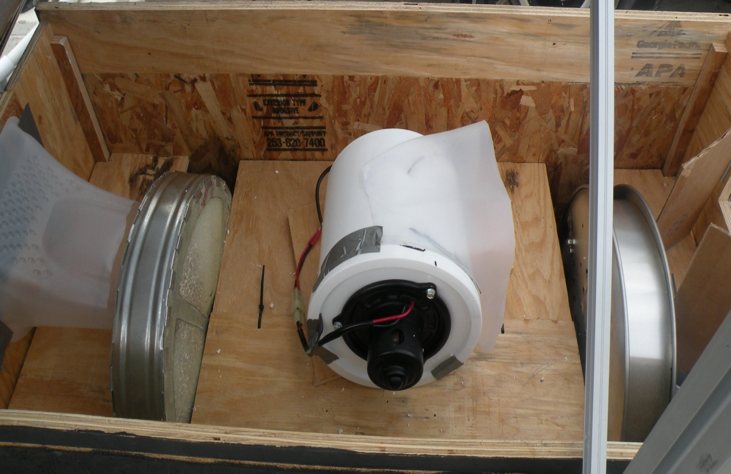
Figure 7. Cooling Cycle – consists of Desiccant wheel, blower, and cooling wheel.
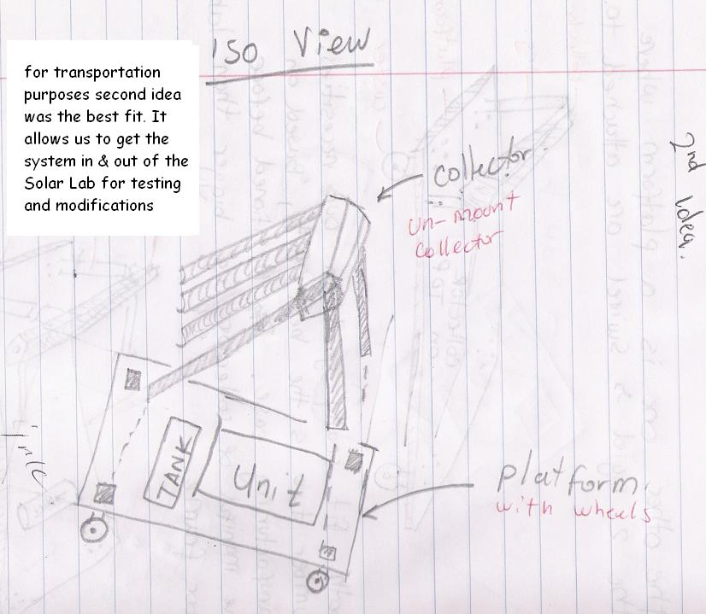
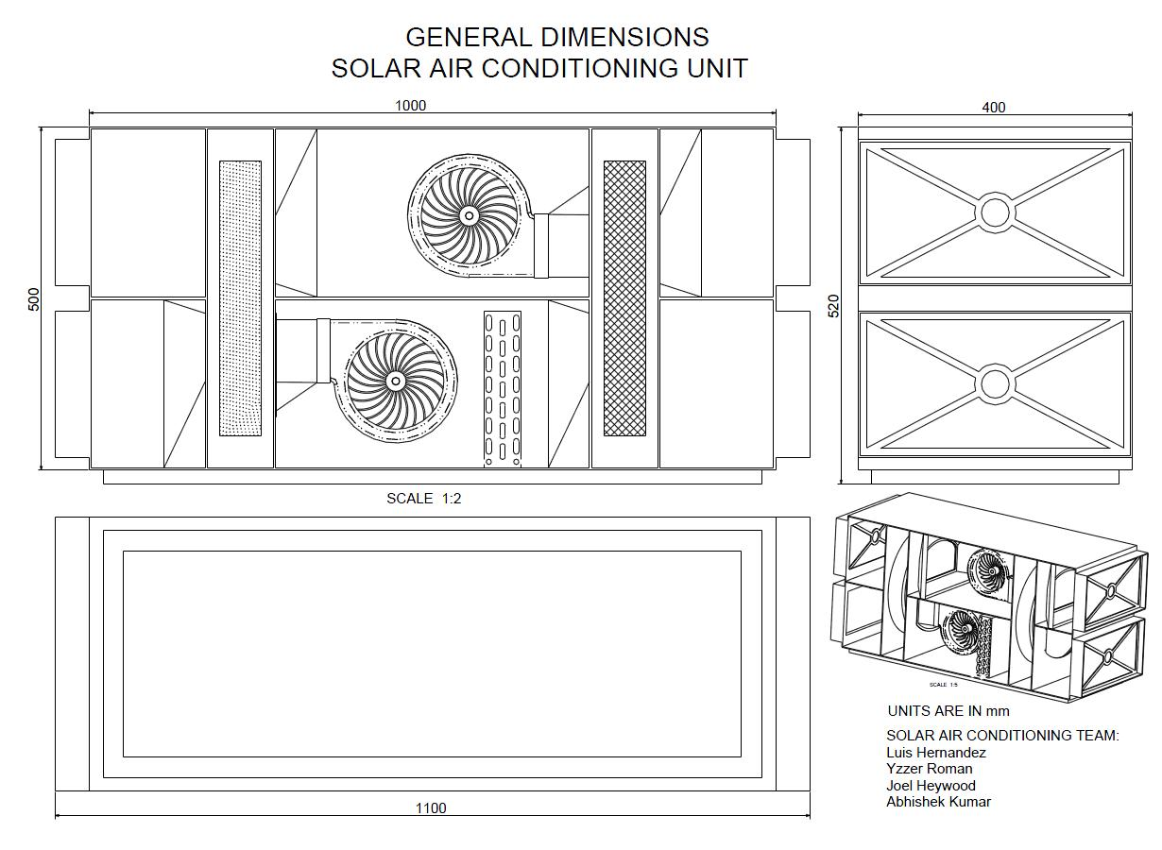
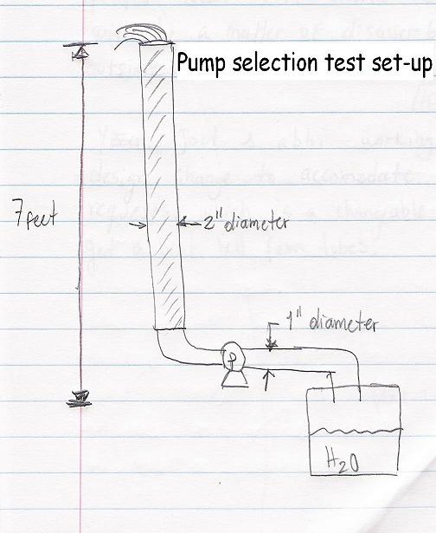
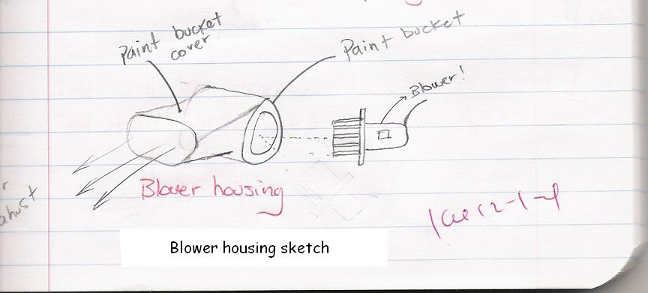
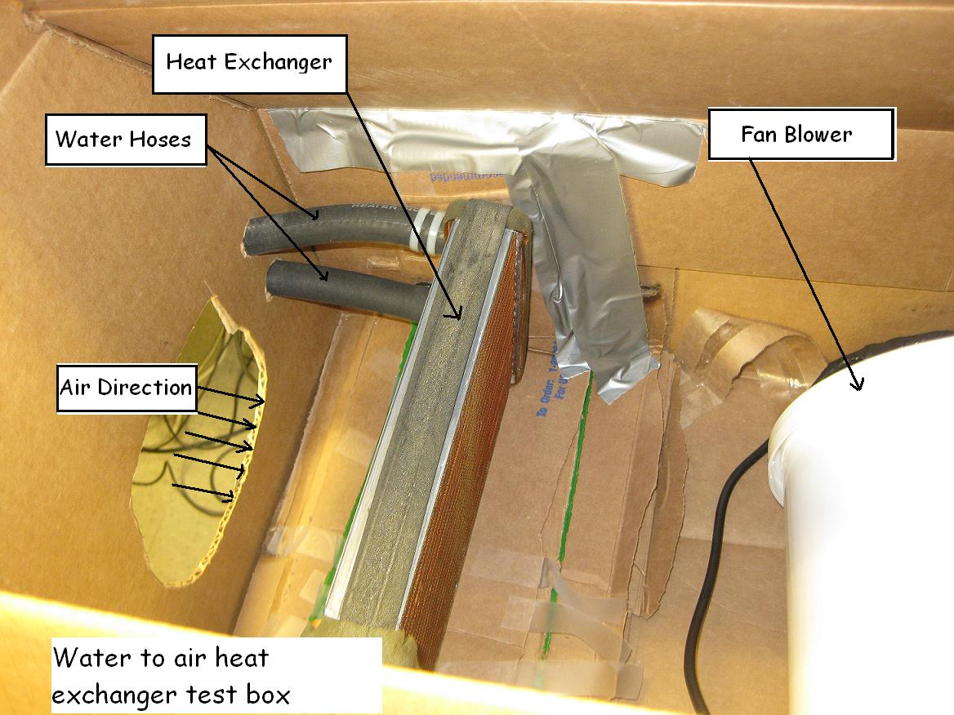
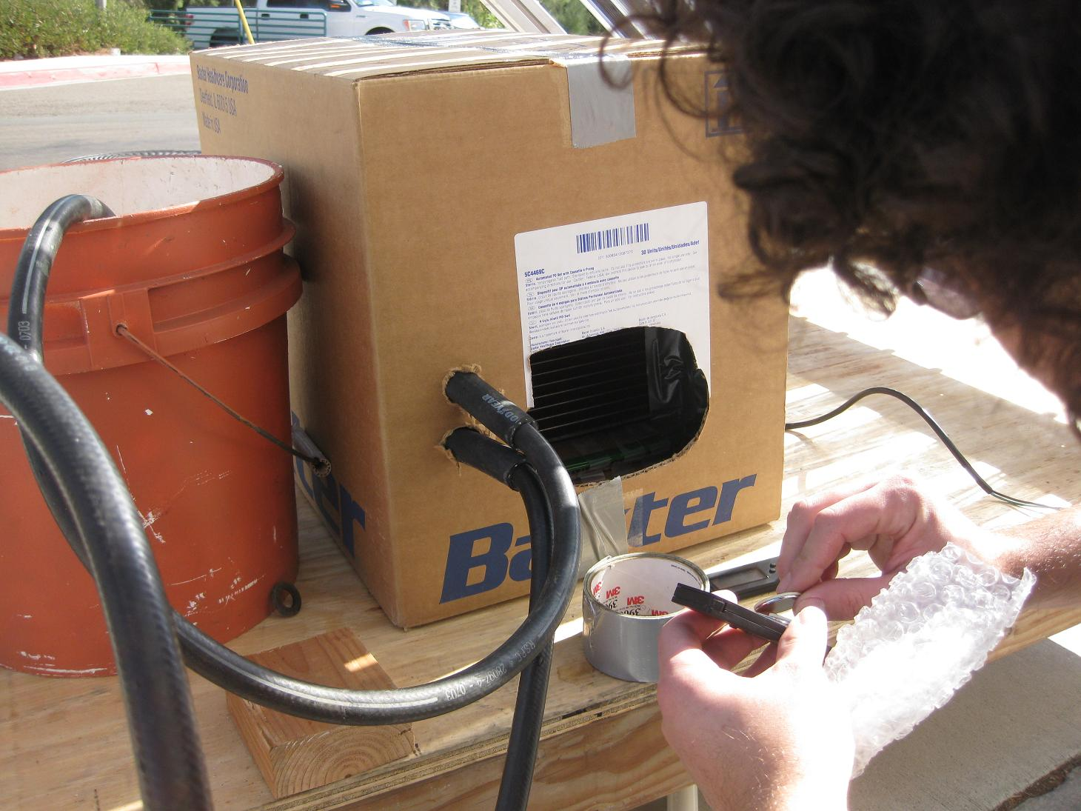
References
[1.] Pollution due to traditional air conditioning systems.
http://www.csd509j.net/cvhs/staff/cornelp/APES/Readings/Chapters16-18/17AC.doc
[2.] Rotartica’s Solar-Powered Air Conditioning
http://www.ecofriend.org/entry/rotartica-s-solar-powered-air-conditioning/
[3.] Novel Aire Technologies Software
http://www.novelaire.com/technologies/home.htm
[4.] Solar rating of Collector (SRCC)
http://www.solar-rating.org/SUMMARY/Dirsum.pdf
[5.] Friction loss in copper pipes.
http://www.engineeringtoolbox.com/friction-loss-copper-steel-plastic-pipes-d_807.html
[6.] Desiccant Wheel Selection
http://www.novelaire.com/technologies/pdfs/dw-brochure.pdf
[7.] Experimental investigation of solar desiccant cooling installation – By Bourdoukan, Wurtz, Joubert http://www.sciencedirect.com/

